Radar Setup

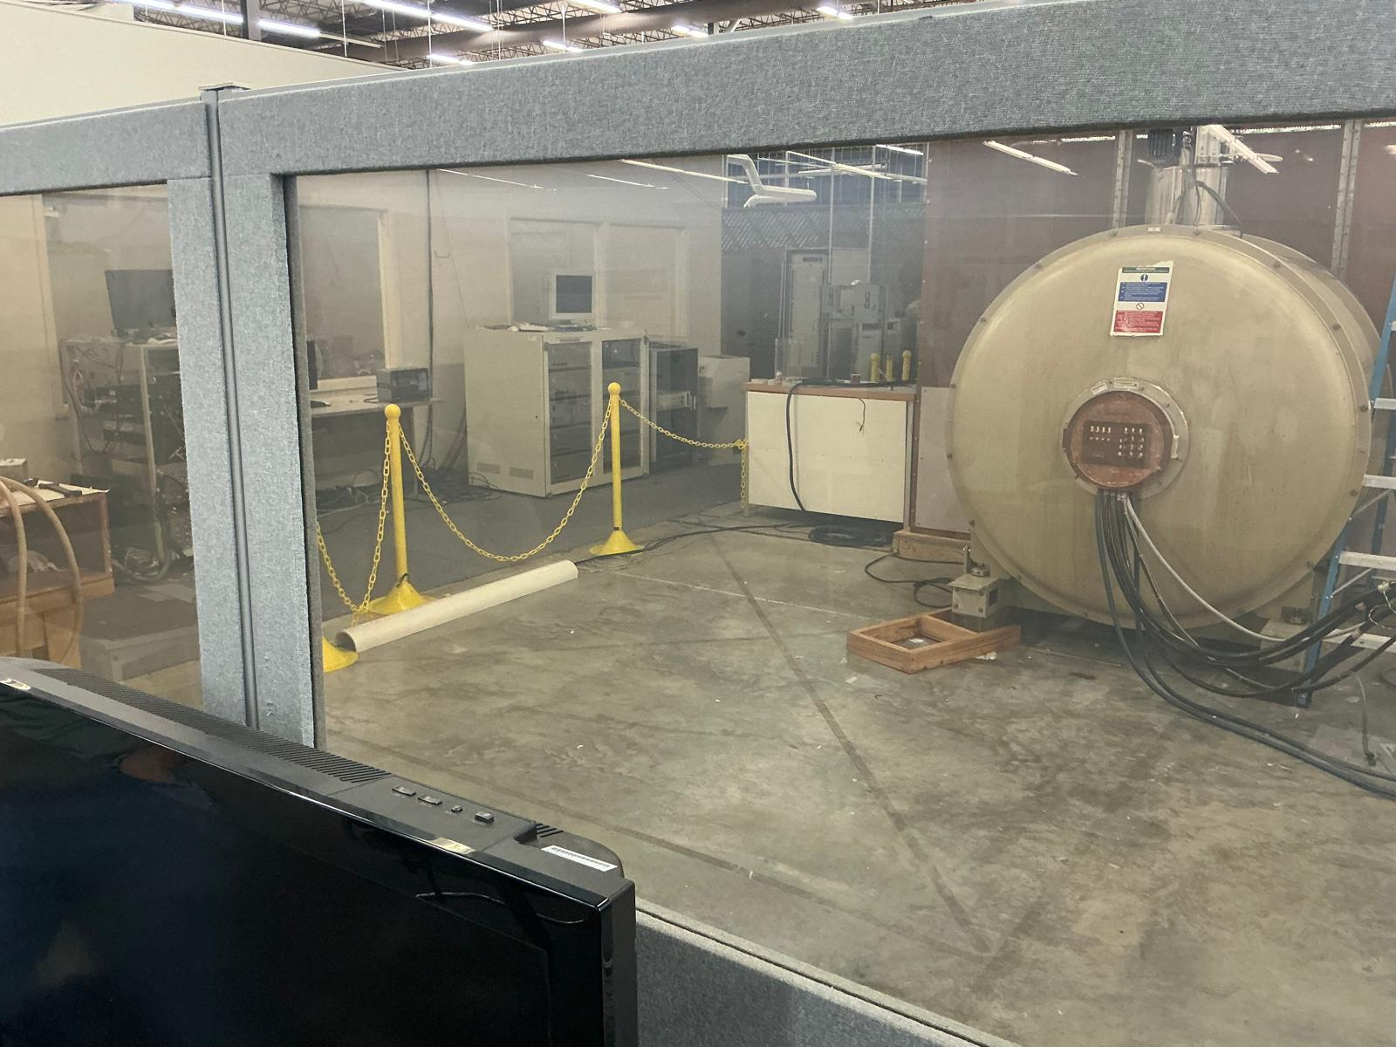

Option 1: Radar on wall
Option 2: Radar on stand (height adjustable)
- Radar mounting options discussed:
  - Wall mount is the safer baseline option
  - Possible to use a height-adjustable nonmetal stand only if made from safe materials and approved for the MRI environment
  - Do not hand-hold the radar during scanning
  - Avoid normal metal tripods, lab stands, spring clamps, or magnetic mounts

Phantom Setup

- Main testing goal: create a small, repeatable moving phantom that fits inside the 20 cm bore and produces controlled motion so the MRI scan shows motion corruption that our project can detect and correct.
- General phantom requirements / restrictions:
  - Must fit comfortably inside the 20 cm diameter bore
  - Should be small, simple, and repeatable
  - Should use nonmetallic / nonmagnetic materials
  - Should avoid metal springs, screws, clamps, and magnetic parts
  - Should avoid air gaps / bubbles when possible
  - Should be easy to place on a sled or holder
  - Motion should be small and controlled, not large or random
  - Phantom should return to the same original position each time if possible
- Best feasible phantom option: small plastic water bottle or vial filled with water
  - Easiest and lowest-work option
  - More uniform and repeatable than fruit
  - Should be filled almost completely with water
  - Should have little to no trapped air
  - Can be mounted on a small plastic sled
- Feasible quick-test phantom option: small tangerine / clementine / orange
  - Can work for a rough early test
  - Easy to get and small enough for the bore
  - Not ideal because it is not uniform, has segments / peel / natural variation, and may contain tiny air gaps
  - Less repeatable and harder to defend as a clean engineering phantom
- Not preferred phantom option: tennis ball filled with water
  - Feasible in theory, but not a good choice
  - Requires cutting, filling, resealing, and removing air
  - Starts with a large air-filled hollow inside
  - Fuzzy outer surface makes mounting and motion less clean
  - More work and less controlled than a small water bottle
- How to create motion:
  - Place the phantom on a small plastic sled / tray
  - Sled moves along a simple plastic track
  - Motion can be along the bore axis horizontally
  - Track should guide the phantom so it moves a small amount without wobbling
- Feasible reset / return methods discussed:
  - Manual reset: simplest option; pull to one side, then manually place back before next scan
  - Gravity return: put track on a slight incline so phantom slides back when string is released
  - Double-string method: one string pulls forward, one pulls back
  - Elastic return: elastic on opposite side pulls phantom back, but may introduce bounce
- Best motion method for least work:
  - Thin nylon fishing line attached to the sled
  - Pull from the MRI opening to shift the phantom a few millimeters
  - Keep motion small and repeatable
- String / pull restrictions:
  - Use thin nonmetallic nylon string
  - Keep the string out of the imaging region as much as possible
  - Avoid letting the string shake, vibrate, or cross through the radar line of sight unnecessarily
  - The string itself is usually less of a problem than uncontrolled pulling motion

Scan Parameters

Radar-MRI Synchronization (TTL?…Other options)

- Use one shared scan-start reference so both datasets have the same “time zero.”
- Timestamp the radar cardiogram continuously during the full scan.
- Record MRI timing parameters such as TR, acquisition order, and total number of lines/frames.
- Compute MRI acquisition times from the scan parameters so each k-space line or data block has an estimated timestamp.
- Use any MRI trigger pulse if available as a cleaner alignment marker.
- Create one intentional motion event during testing that is visible in both the radar signal and the MRI data, then use it as a check.
- Keep the phantom motion repeatable so alignment errors are easier to detect.
- Use the same system clock / logging clock when possible for all saved timing data.
- Check that the radar peaks line up with the expected MRI motion-corrupted periods after alignment.
- Validate alignment numerically by measuring timing mismatch and making sure it stays within an acceptable error range.

